1.table creation department1

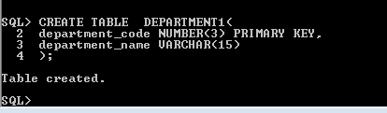

2. Insert data

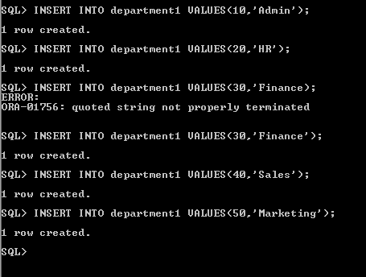

3. creation of employee3 table

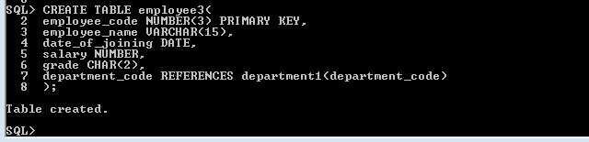

4. insert data into employee3 table

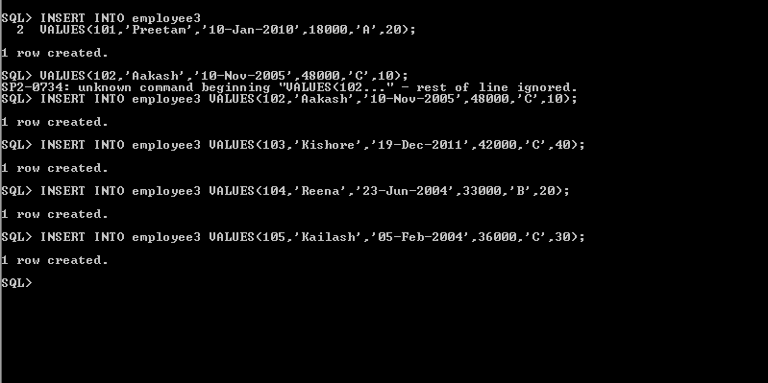

**Queries**

1.

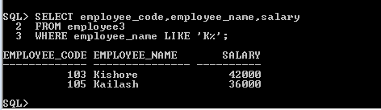

2.

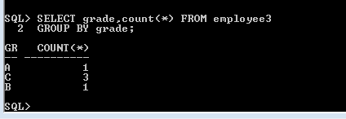

3.

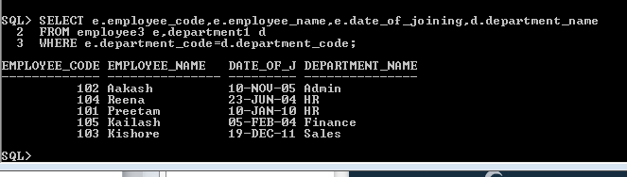

4.

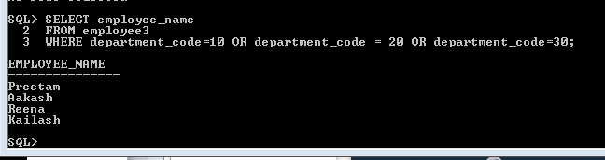

5.

